STAR SEARCH 2017

**Who will be the Fort Worth Association of Federated Women’s Clubs next BRIGHT SHINING STARS?**

Looking for young ladies throughout the metroplex who are:

* High School Freshman, Sophomore, Junior or Senior
* Energetic and Enthusiastic
* Excited to learn about:
* Business and Social Etiquette
* Speech & Public Speaking
* Ballroom Dancing

Candidates will gain exposure to cultural and civic organizations and the media as well as enjoy the experience of a formal presentation where Miss City Federated will be crowned and awarded a $1000.00 scholarship.

All interested candidates must submit their application by November 15, 2016. Training will begin in December.

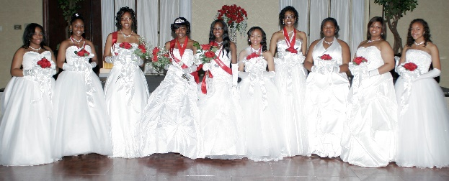

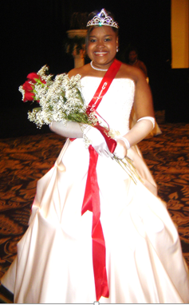

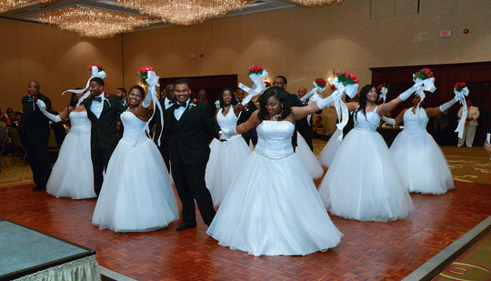

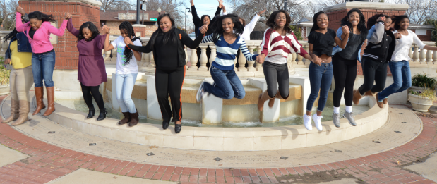

**Fort Worth Association of Federated Women's Clubs**

**2017 COTILLION**

**Cotillion Committee**

**1051 Evans Avenue ~ Fort Worth, TX 76104**

**(817) 817-437-1780 Phone ~ (817) 887-3919 Fax**

[**Tmskvb2@yahoo.com**](mailto:Tmskvb2@yahoo.com)

**Fort Worth Association of Federated Women’s Club**

**2017 COTILLION**

**CONTESTANT INFORMATION**

*(Please print legibly)*

Full Name:

Address:

City: State: Zip:

Home Phone: Mobile Phone:

Email:

Age: School attending:

Father:

Mother:

Grandparents:

Special persons in your life:

Club Sponsor (if known):

Gifts, Talents & Hobbies:

Academic achievements, honors, awards, scholarships:

Organizations, church, extracurricular activities:

Future college plans & major:

Favorite Scripture:

**Return this form to:**

**Fort Worth Association of Federated Women's Clubs, Attn: 2017 Cotillion Committee, 1051 Evans Ave., Fort Worth, TX 76104 ~ (817) 437-1780. Feel free to fax or email. Fax: (817) 887-3919, Email** [***tmskvb2@yahoo.com***](mailto:tmskvb2@yahoo.com)